|  |  |  |  |  |
| --- | --- | --- | --- | --- |
| Description: Vertical full colour positive | Safety Bay Senior High School | | | |
| **CHEMISTRY UNIT 3 & 4** | | | | |
| **Practical Test #2:** | | | | |
| **Titrations (theory component)** | | | | |
|  | | | | |
| **NAME:** | | |  | |
|  | | |  | |
| **Time allowed for this paper** | | | | |
| Reading time: | | 5 minutes | | |
| Working time: | | 50 minutes | | |
|  | | | | |
| **Structure of this paper:** | | | | |
| Section | | | Marks available | Marks Obtained |
| Theory component | | | 53 | _____ / 53 |
| Practical component | | | 12 | _____ / 12 |

**Total: /65**

**Section One: Multiple Choice**

This section has 6 questions. Answer **all** questions by circling the correct option. If you make a mistake, put a cross through your answer and then circle your new answer. No marks will be given if more than one answer is completed for any question.

Suggested working time: 5 minutes

1. Which type of glassware is used in a titration to deliver an accurate volume of solution to a known volume of another solution?

|  |  |  |  |  |  |  |  |
| --- | --- | --- | --- | --- | --- | --- | --- |
| (a) |  | (b) |  | (c) |  | (d) |  |

1. Which one of the following sets of titres indicates a systematic error if the actual volume being measured is 85.2 mL?
   1. 85.1 mL, 85.1 mL, 85.3 mL, 85.5 mL
   2. 65.2 mL, 75.2 mL, 85.2 mL, 95.2 mL
   3. 85.2 mL, 85.3 mL, 85.1 mL, 85.1 mL
   4. 87.3 mL, 86.9 mL, 89.1 mL, 88.2 mL
2. In an acid-base titration, which of the following is least likely to cause an error in the calculated concentration?
   1. using a funnel in the burette and leaving it in the same place for each titration
   2. measuring the volume at the bottom of the meniscus
   3. each member of the experimental team taking turns to measure the burette
   4. rinsing the burette with distilled water before the titration
3. Sulfuric acid (H2SO4) and nitric acid (HNO3) are both strong acids. Ethanoic acid (CH3COOH) is a weak acid.

20.00 mL solutions of 0.10 mol L-1 concentration of each of these three acids were separately titrated with a 0.10 mol L-1 solution of sodium hydroxide (in the burette).

0.10 mol L-1

H2SO4

0.10 mol L-1

HNO3

0.10 mol L-1

CH3COOH

Which of the following statements is true regarding the volume the NaOH needed for each titration?

* 1. All three acids would require the same amount of NaOH
  2. HNO3 would require more NaOH than CH3COOH, but less than H2SO4
  3. H2SO4 and HNO3 would require the same amount of NaOH, but CH3COOH would require less
  4. CH3COOH and HNO3 would require the same amount of NaOH, but H2SO4 would require more

1. The best definition of the equivalence point in an acid-base titration is the point at which the

* + - * 1. indicator changes colour.
        2. volume of acid equals the volume of base.
        3. pH of the solution is 7.
        4. mole ratio of acid to base is equal to their stoichiometric ratio

1. The pH ranges for the colour change of four indicators are given below.

|  |  |
| --- | --- |
| Alizarin yellow | 10.1 – 12.0 |
| Crystal violet | 6.4 – 8.2 |
| Bromocresol green | 3.8 – 5.4 |
| Malachite green | 0.2 – 1.8 |

Which one of the indicators in the table is **most** suitable for the titration of hydrochloric acid with potassium carbonate solution?

1. Alizarin yellow
2. Crystal violet
3. Bromocresol green
4. Malachite green

**Section Two: Short Answer**

Write your answers in the spaces provided. When calculating numerical answers, show your working or reasoning clearly. Express numerical answers to the appropriate number of significant figures and include appropriate units where available.

Suggested working time: 45 minutes

**Question 7** **(3 marks)**

The following images show initial and final readings from a burette during a titration.

Find the titre volume for this titration. **Give answers to an appropriate number of significant figures.**

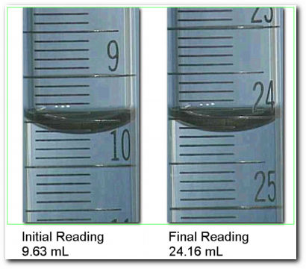

Initial volume = __________ mL

Final volume = __________ mL

Titre volume = __________ mL

**Question 8** **(12 marks)**

*The following information relates to the vinegar titration you performed earlier this week. Use the provided data to complete the calculations for your experiment*. *A copy of the method has been provided as a reminder.*

|  |
| --- |
| **Part 1: Dilution of vinegar**  Commercial vinegar is much more concentrated than the sodium hydroxide we will use, so it will require dilution before it can be titrated. Use a 20.00 mL volumetric pipette and a 250.0 mL volumetric flask to prepare a diluted vinegar solution.  **Part 2: Titration against 0.129 M sodium hydroxide**  This titration will be performed with the sodium hydroxide solution in the burette and 20.0 mL of diluted vinegar in a conical flask. Perform a number of titrations until you have achieved consistent results. |

**Student results:** Average titre volume: 11.15 mL

Concentration NaOH: 0.129 mol L-1

* 1. Assuming the student followed the procedure correctly, list the solution the student would have rinsed each piece of glassware with during **Part 2** of the experiment. (3 marks)

|  |  |
| --- | --- |
| **Equipment** | **Rinse with:** |
| Burette |  |
| Pipette |  |
| Conical flask |  |

* 1. Write a balanced chemical equation for this reaction. (1 mark)

* 1. Calculate the concentration of CH3COOH in the **diluted** vinegar solution. (3 marks)

* 1. Calculate the mass of CH3COOH in the original 20.00 mL of vinegar. (3 marks)

* 1. The density of commercial (undiluted) vinegar 1.01 g/mL. Find the concentration of CH3COOH in commercial vinegar, expressed as a %mass/mass. (2 marks)

**Question 9** **(5 marks)**

Benzoic acid is a weak acid used as a preservative, for example in soft drinks. In aqueous solutions it ionises according to the following equation:

C6H5COOH(aq) ⇌ C6H5COO⁻(aq) + H+(aq)

The graph below shows the changes in pH that occur when 20.00 mL of approximately 0.100 mol L-1 benzoic acid solution in a conical flask is titrated with 0.200 mol L-1 NaOH solution from a burette.

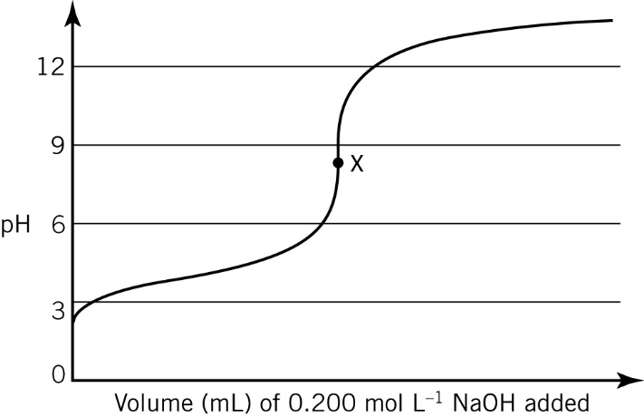

* 1. At point X, approximately what volume of NaOH solution has been added to the conical flask?

(1 mark)

* 1. The indicator bromophenol blue changes colour between pH 3.0 (yellow) and pH 4.6 (blue). Explain whether or not bromophenol blue would be a suitable indicator for this reaction. (2 marks)

* 1. The reaction between benzoic acid and sodium hydroxide is often referred to as a ‘neutralisation reaction’, yet the pH of point X is not 7. Explain with the aid of a chemical equation why this is so.

(2 marks)

**Question 10** **(7 marks)**

A student attempted to determine the concentration of a hydrochloric acid solution. The following steps were performed.

Step 1: A conical flask and 25.00 mL pipette were rinsed with distilled water.

Step 2: The student filled the 25.00 mL pipette with a standard solution of sodium carbonate to the level shown in the diagram.

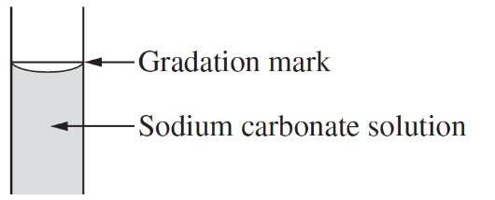

Step 3: The standard sodium carbonate solution in the pipette was transferred to the conical flask. The student ensured that all of the sodium carbonate solution was transferred to the conical flask by blowing through the pipette. They then rinsed the inside of the conical flask using distilled water.

Step 4: Two drops of an appropriate indicator were added to the conical flask.

Step 5: A burette was rinsed with hydrochloric acid solution and then filled with hydrochloric acid. The student then carried out the titration to determine the concentration of HCℓ.

* 1. The student made at least three procedural errors in their titration. Complete the table by describing three mistakes the student made, and then show how each error would affect the volume of HCℓ required for neutralisation. (6 marks)

|  |  |
| --- | --- |
| **Mistake in procedure** | **Effect on volume of HCℓ needed** (tick one ☑ ) |
|  | ☐ Increased volume of HC`ℓ needed  ☐ Decreased volume of HCℓ needed  ☐ No effect on volume of HCℓ needed |
| ``` | ☐ Increased volume of HCℓ needed  ☐ Decreased volume of HCℓ needed  ☐ No effect on volume of HCℓ needed |
|  | ☐ Increased volume of HCℓ needed  ☐ Decreased volume of HCℓ needed  ☐ No effect on volume of HCℓ needed |

* 1. Name an indicator that might have been used in Step 4 (1 mark)

**Question 11 ( 9 marks)**

Borax, Na2B4O7·10H2O, can be used as a primary standard in acid-base titrations. It reacts according to the following equation:

B4O72- + 2 H+ + 5 H2O → 4 H3BO3

2.334 g of bora x was dissolved in a 250.0 mL volumetric flask and the flask filled to the mark with distilled water. 20.00 mL aliquots of the borax solution were titrated against a hydrochloric acid solution and the following results were obtained.

|  |  |  |  |  |
| --- | --- | --- | --- | --- |
|  | 1 | 2 | 3 | 4 |
| Final reading (mL) | 20.20 | 36.80 | 21.07 | 37.70 |
| Initial reading (mL) | 2.55 | 20.20 | 4.35 | 21.07 |
| Titration volume (mL) |  |  |  |  |

Calculate the concentration of the hydrochloric acid solution. (9 marks)

**Question 12** **(11 marks)**

The official analysis method for aspirin (acetylsalicylic acid) is to dissolve a sample in sodium hydroxide solution and titrate the excess hydroxide with standard hydrochloric acid, using phenol red indicator. The reaction of aspirin with hydroxide is given by:



Aspirin tablets contain acetylsalicylic acid and an unreactive binding material.

To analyse a supply of aspirin tablets claimed to contain 300 mg of acetylsalicylic acid in each tablet, 20 tablets weighing a total of 7.576 g were crushed and a sample of powder weighing 0.619 g was gently boiled for 10 minutes with 30.00 mL of **approximately** 0.5 mol L-1 NaOH. After cooling, the solution was titrated with 0.548 mol L-1 HCℓ using phenol red indicator. 17.62 mL of HCℓ was required.

In a separate ‘blank’ titration, 30.00 mL of the same approximately 0.5 mol L-1 NaOH was gently boiled for 10 minutes, cooled and titrated with the standard 0.548 mol L-1 HCℓ. The volume of HCℓ required was 27.65 mL.

* + - 1. How many moles of sodium hydroxide were consumed in the reaction with the 0.619 g of powdered sample? (5 marks)

* + - 1. What mass of acetylsalicylic acid, C9H8O4, was in the 0.619 g sample of powder? (2 marks)

* + - 1. How many tablets does 0.619 g of powder represent? (1 mark)

* + - 1. What is the mass of acetylsalicylic acid (in mg) per tablet? (2 marks)

* + - 1. The British Pharmacopoeia (an authoritative catalogue of drugs) requires that aspirin tablets contain 95-105% of the mass of acetylsalicylic acid claimed. Do the tablets fit this requirement? Justify your answer. (1 mark)

**SPARE WORKING SPACE**

If you need to use this space to continue an answer, indicate in the original answer space that your question is continued on this page.

**SPARE WORKING SPACE**

If you need to use this space to continue an answer, indicate in the original answer space that your question is continued on this page.